# **Troubleshoot Azure monitoring setup**

This page presents common troubleshooting scenarios for Azure monitoring setup.

**Why don’t I see metric data?**

If you have missing or wrong metrics:

* Verify the charts in Azure Portal Monitor with Dynatrace [Data explorer](https://www.dynatrace.com/support/help/observe-and-explore/explorer).
* Make sure that you compare the same periods.
* Make sure you compare data with the same resolution in Azure and Dynatrace (for example, one data point per minute, 12:43-12:44). We recommend that you compare data with a one-minute resolution whenever possible.
* Make sure that you compare granular data split across as many dimensions as possible (Azure: filter/split by).
* Make sure that you compare the same type of aggregated data (average with average, minimum with minimum, maximum with maximum).
* Check aggregation functions. If the detailed data shows no discrepancies, you can assume that the underlying data from Azure was imported correctly. Any differences observed when viewing less detailed, aggregated data can result from the method used to group the data over time (SUM/AVG/MIN/MAX) or over dimensions (for example, merging data from multiple combinations of dimension values into a single data point).
* Example 1: Five data points representing a one-minute period can be aggregated into a single data point for a five-minute period.
* Example 2: Data from various regions (,uch as "region=east-us, responseStatus=400", "region=west-us, responseStatus=200") can be combined into a single data point representing the total number of responses across all regions.

**What if I have more than one ActiveGate?**

If you have more than one ActiveGate, you have the following options:

* Confirm that all ActiveGates with Azure monitoring enabled can connect to Azure.
* ActiveGate version 1.261+ Designate an ActiveGate with which you want to monitor your Azure subscription. Any ActiveGate type works properly as long as it can connect to Azure.

1. On the designated ActiveGate, edit the custom.properties file and set the azure_monitoring_enabled property to true:

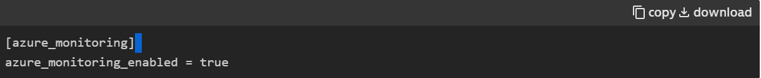

1. On the other Active Gates, edit the custom. properties file and set the azure_m onitoring_enabled property to false.

**Time frame comparison: Custom timeframe versus Last X**

It is crucial to choose the appropriate timeframe option based on your needs.

* Last X displays only the most recent value of the selected metric.
* Custom timeframe allows you to specify a time range and view the average value over that period.

For example, if you select Last 2 hours, you'll only see the most recent value from the past two hours. However, if you select a custom timeframe of Last 2 hours, you'll see the average value for the metric over the entire two-hour period.